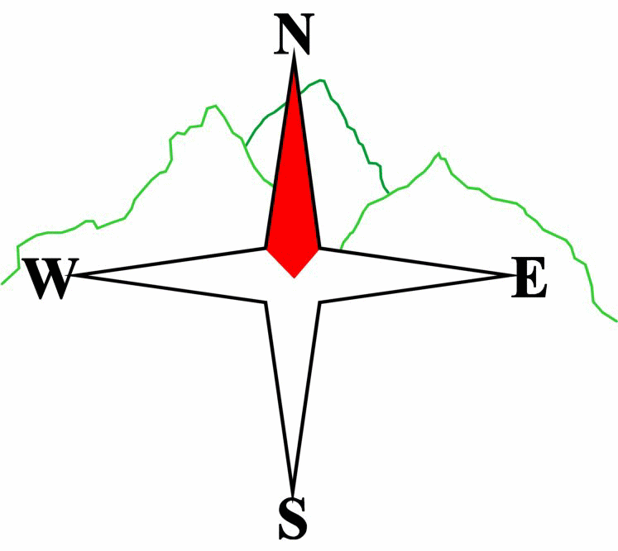
Blairgowrie & District Hillwalking Club

www.bdhc.org.uk
An Caisteal

21/04/2024
O.S. Map No: 50

Car times: | Alyth (Square): 07.15 |  | Blairgowrie (Wellmeadow): 07.30  Perth (Crieff road opp Tesco): 07.50

A Walk – An Caisteal 995m (M) & Beinn a Chroin 940m (M)
Start layby on A82 at NN370 239. Take path under railway and on bridge over River Falloch. Follow track for approx. 1km, then ascend up flank of Sron Garbh 709m, then path on meandering ridge to An Caisteal 995m. From summit continue south to the bealach, then E up zig zag path avoiding rocky crags to summit of Beinn a Chroin. Head N down grassy ridge and pick up path following west side of River Falloch to return to start point.

Approx. distance: 14 km |  | Total ascent: 1045 m |  | Min. walking time: 5½ hrs

B Walk – An Caisteal 995m (M)
As A Walk to summit of An Caisteal. From summit head initially SW, then NW on ridge to reach Stob Glas 710m, then descend NNW to reach track (not on 1:50 map) at around NN 362 216. Follow track W to Derrydarroch and cross bridge over river Falloch to reach A82.

Approx. distance: 12 km |  | Total ascent: 890 m |  | Min. walking time: 4½ hrs
B & C Walk – Bridge Of Cally to Blairgowrie  Join Cateran Trail at Bridge of Cally. Same route as A walk from NO 147 483.  Approx. distance: 14 km Total ascent: 224 m Min. walking time: 4 hrs |  |  |  |  |  | Min. walking time: 5.25 hrs

C Walk – West Highland Way: Ardleish to Derrydarroch (C+ Option to Crianlarich)
Catch 10am Ferry at Ardlui to cross to Ardleish. Follow WHW from Loch Lomond on E side of River Falloch passing Falls of Falloch and joining A82 after Derrydarroch (as B Walk).
C+ Alternative for faster walkers: Continue on WHW to Crianlarich.

C: Approx distance: 9 km Total ascent: 280 m. Min walking time: 3½ hrs @3kph
C+: Approx.distance:15 km |  | Total ascent: 400 m.  Please note that the Minimum walking times are based on reasonably fast walkers and assuming good conditions. The times do not include stops or breaks.  In poor weather conditions or if members are not comfortable walking at 4km/hour then alternative or shorter routes should be considered. Experienced members may devise their own routes (min 3 walkers) but must inform the Meet Sec and return to the end point at the agreed time. |  | Min. walking time: 4½ hrs @4kph
Club Weekend Away 11-13 May – Keswick / Borrowdale
Next club walk – Jock’s Road on Sunday 2nd June, 07.30 Wellmeadow

IMPORTANT: YOUR SAFETY IN THE HILLS
The Committee reminds members and guests of the following important points:
- You are responsible for your own safety  - Club officials are not trained mountain leaders  - Are you fit enough to complete your chosen walk in the available time?  - Know where you are going on the walk and follow the route on your map.  - Know how many are in your party and stay together | - Ensure you have enough food plus emergency rations  - Carry a map & compass, survival bag, torch, whistle and small first aid kit. Know how to use them.  - In winter conditions you must carry an ice axe on high level walks (club rule). You are also recommended to carry crampons.  - Learn how to use your equipment.
Club officials will be happy to give advice on any of these points if requested.

